1.
Edgegar and Middleine
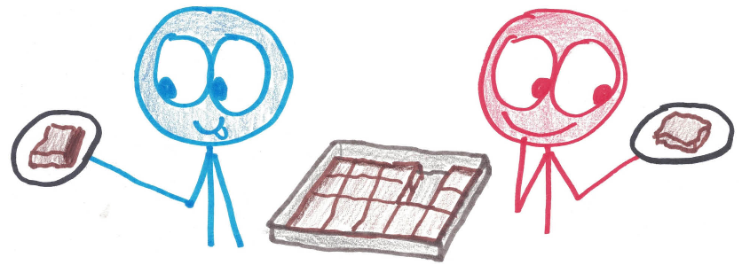
As it turns out, there are precisely two different rectangular pans that will give equal numbers of edge and middle brownies. What are they?

Solution
The two pans are 6 x 8 (yielding 48 brownies) and 5 x 12 (yielding 60 brownies).
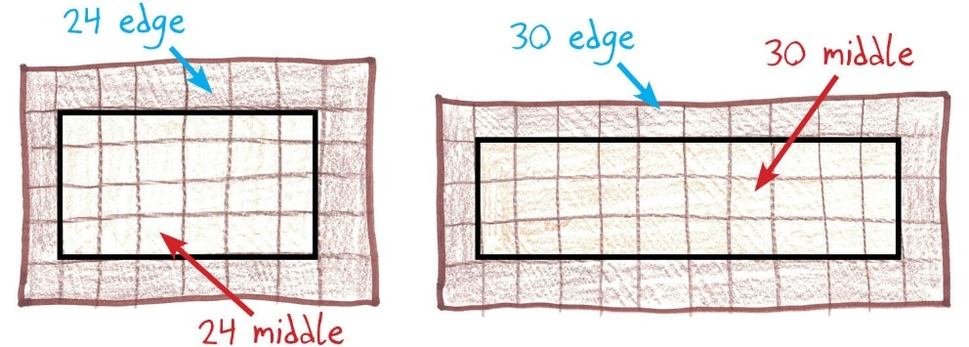

2.
Proving It
Can you prove that these are the only two solutions?

Proof
Say the whole pan is MxN, with M being the smaller dimension. We require that the whole pan be precisely double the interior; that is, MxN = 2(M – 2)(N – 2).
This cannot occur if M = 2 (because there’s no interior at all).
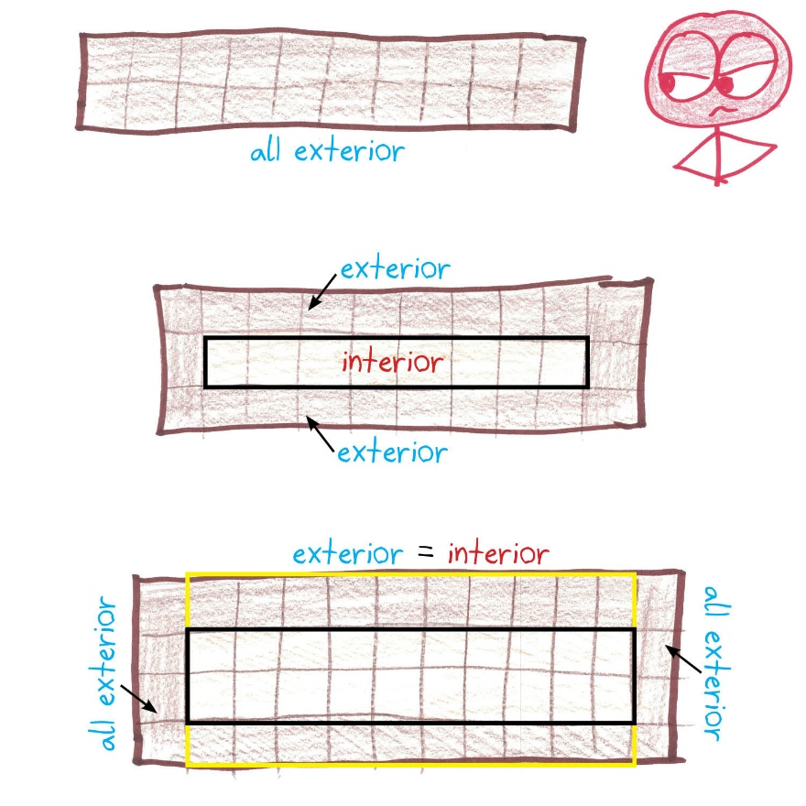
Nor can it work with M = 3 (because the interior comprises only one row of brownies, and the exterior has two).
Nor even with M = 4 (in which case each column will have two edges and two middles, except for the first column and the last column, each with four edges and no middles).
Thus, M = 5 is the smallest number to consider; it yields the 5 x 12 solution.
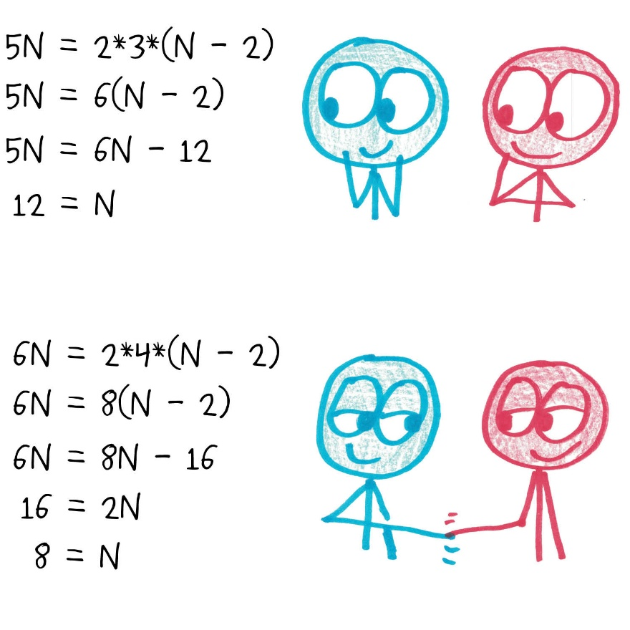
After that, M = 6 yields the 6 x 8 solution.
Pushing onward to M = 7 yields no solutions: already the 7x7 pan is “too big,” with 25 centers and 24 edges, and the imbalance only grows for larger pans.
3.
New Ratios
“My own family,” writes Joshua, “has three Edgegars and one Middleine.” What pans will give precisely three times more edge brownies than middle brownies?
Conversely, what pans will give three times more middles than edges?

Solutions
Josh’s family can use the 3x8 (yielding 24 brownies) or the 4x4 (yielding 16 brownies).
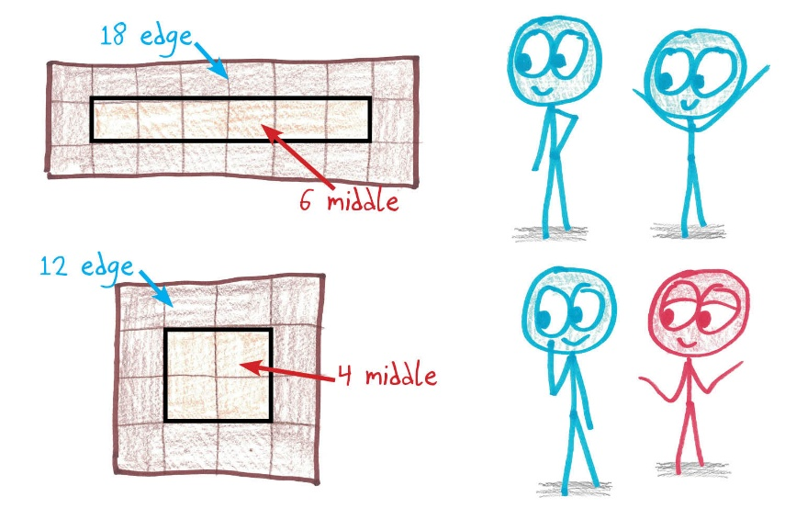
For the reverse—three times as many middles—there are five solutions (all enormous):
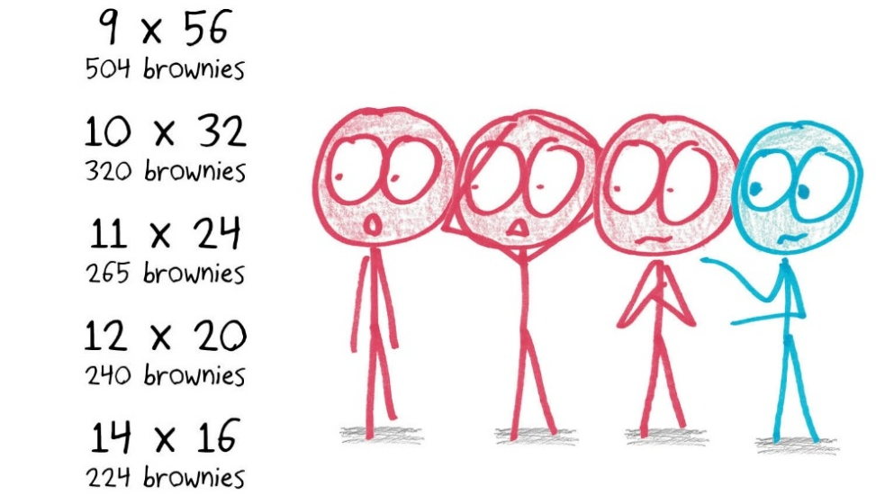
5.
3D Loaves
Let’s give Edgegar and Middleine a recipe for brownie loaves: 3D chocolate confections that are sliced into little brownie cubes. As before, Edgegar prefers exterior cubes, and Middleine prefers interior cubes. Can you find a three-dimensional pan size (a x b x c) with equal numbers of exterior and interior cubes?
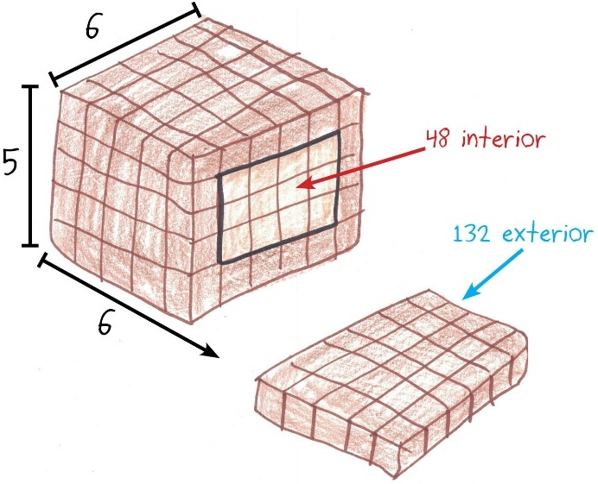

Solutions
Using logic similar to the proof (#2), the smallest dimension must be greater than 4 (lest it have too many exteriors) and smaller than 10 (lest it have too many interiors).
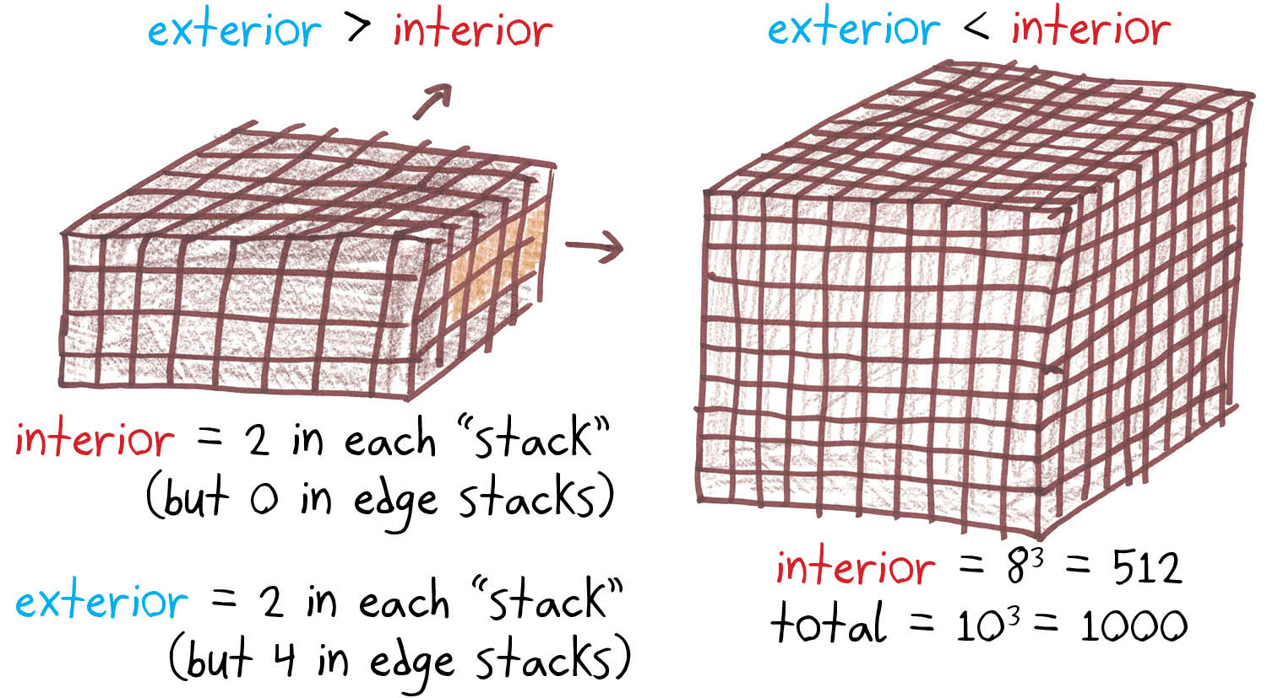
Let’s fix the smallest dimension as 5. We now seek M and N so that 5MN = 6(M – 2)(N – 2). You’ll find that M = 12 is too small, as it gives the impossible 60N = 60(N-2). So we can consider values starting at M = 13, and solve each for N. Eight solutions emerge:
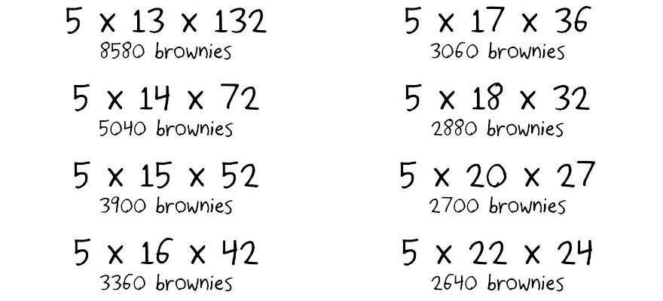
If the smallest dimension is 6, similar methods yield five solutions. Likewise with 7 (four solutions) and 8 (three solutions).
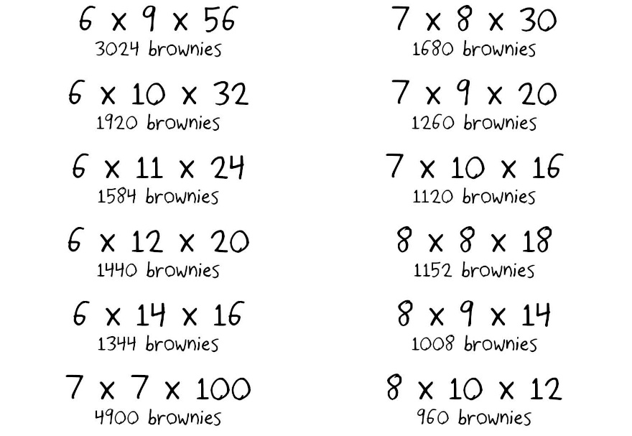
With a smallest dimension of 9, there turn out to be no solutions. So the above list of 20 solutions is exhaustive.
One can generalize to even higher dimensions; see Martin Janecke’s work at oeis.org/A263207, which includes a speedy script for generating all solutions in n dimensions.
I only ask that, when sampling 7-dimensional brownies, you invite me for a taste.

Some Relevant Sequences
How many brownies are required to achieve exactly n middles? See oeis.org/A386318
How many brownies are required to achieve at least n middles? See oeis.org/A386316

Final Notes
I don’t want to be melodramatic here, but Middlelines like myself are evidently born to suffer. First, it is by definition impossible to make middle brownies without edges. We cannot live without our Edgegars. Yet the reverse is untrue; the Edgegars do not need us. To us, the relationship is symbiosis; to them, it’s parasitism.
You see, it’s easy to add more edge brownies by crenelating your pan, as in this clever alternate solution to the original problem by Tifin Calcagni’s fourth-grade students.
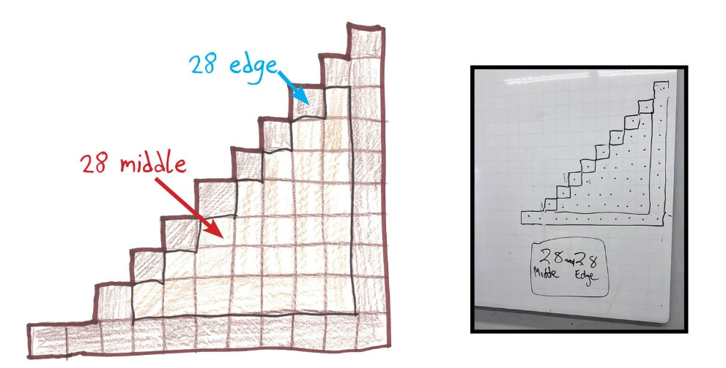
So the math is stacked against us. And worse, popular opinion is stacked against us, too.
My informal polling suggests that we Middleines are a distinct minority—and the Edgegars will not let us forget it. Rather than live in harmony, our delicate delights in peaceful coexistence with their crusty chew toys, these edge-lickers prefer to heap abuses upon us.
“A more elegant solution to the puzzle,” suggested Molly, an otherwise gentle soul, would be “just doing 100x1 and leaving Middeline to the consequences of bad taste.”
See what I’m dealing with here?

There are even brownie pans built on this principle: they have an extra ridge of metal snaking through the interior of the pan, turning every brownie into an edge brownie. Nightmarish stuff.

